
PUCIT
Punjab University College of Information Technology

Final Year Project Proposal

.

Table of Contents

Final Project Proposal Guide 2
1. Introduction 3
1.1 Project Title 3
1.2 Project Overview Statement 3
1.4 Project Goals & Objectives 5
1.5 High-level system components 5
1.6 List of optional functional units 5
1.7 Exclusions 6
1.8 Application Architecture 6
1.9 Gantt chart 7
1.10 Hardware and Software Specification 7
1.11 Tools and technologies used with reasoning 7

Final Project Proposal

1. Introduction

This is an android application which is designed to order the food online while travelling by train. While travelling a long distance by train the main problem we face is food. To overcome such a problem we want to develop a mobile application through which we are ordering the food online. If the person wants to order food he/she can directly order the food so that the food is delivered directly to your seat and the cash-on-delivery process takes place between the customer and the person who delivers the food to us from the particular restaurant which we order.

Project Title
Online Restaurant Food Ordering Service in Train

1.2 Project Overview Statement
User will install the application and register into it by providing some information. After registering into the application user has to enter from and to address. Then the list of restaurants according to location is displayed. Each restaurant displays the menu of a wide variety of food items. From that menu, the user can select the restaurant and food items and can order the food before reaching that particular station.
The order consists of a list of food items along with passenger details like PNR number, train number, compartment number, berth and seat number. When the food is delivered to him, he pays the bill.
On the other hand, the restaurant management receives the order and can see the order in the same app and sends a person to deliver the food to the passenger. As the train waits for sometime in the railway station and with the help of passenger’s details, the restaurant person can get on the train and deliver the food to passenger and collects the bill amount. The mode of payment is cash-on-delivery. Also, there is a facility of complaint box, where complaints about the quality of food can be given to restaurant management. So that the restaurant management can improve their quality of service. The restaurant management can see the list of orders date-wise.

1.2 Project Overview Statement Template
Project Title:
Online Restaurant Food Ordering Service in Train

Group Leader: Sidra Khan
Project Members:
Name | Registration # | Email Address | Signature
Arooj Jamil |  | Mcsf18m037@pucit.edu.pk
Ayesha Zafar |  | Mcsf18m023@pucit.edu.pk
Amina Pervaiz |  | Mcsf18m047@pucit.edu.pk
Sibgha Mushtaq |  | Mcsf18m010@pucit.edu.pk
Sidra Khan |  | Mcsf18m035@pucit.edu.pk

Project Goal:
To provide Restaurant food service to passengers while traveling by Train

Objectives:
Sr.#
1 | To manage details of Customers
2 | To manage details of Restaurants
3 | To manage orders and carts
4 | To manage payments efficiently

Project Success criteria:
Customers will successfully place orders and their orders will entertain on time.

Assumptions, Risks and Obstacles:
Assumptions:
- We assume that train will never be late in order to deliver order at time
- Application will work correctly
Risks:
- Database problem
- Tool expertise and skills
- Quality risk
- Requirement gathering
Obstacles:
- Unreliability in delivery & logistics staff.

Organization Address (if any): PUCIT, Lahore.

Type of project: Research Development
Target End users: Train Passengers, Restaurant

Development Technology: Object Oriented Structured
Platform: Web based Distributed
Desktop based Setup Configurations
Android Application________________
Suggested Project Supervisor:Sir Asif Sohail
Approved By:
Date:

1.4 Project Goals & Objectives
1.4.1Goals

To provide the service of restaurant food to passengers while traveling in train. So the passengers can have healthy and fresh food while traveling.

1.4.2 Objectives

To maintain the data on both customer and restaurant side.

To maintain all the information regarding trains, restaurants, orders and payments.

To maintain the train status send by customer in order to tell the time duration, the train will arrived at station.

1.5 High-level system components
Online restaurant food ordering information system:
- The component should have the whole database schema. Database contains all the information about customer, products and restaurants. The data can be added, updated and extracted by the database. It is managed on server side.
Customer interacting application:
- Through this component the customer interact with the system by login and perform the activities like placing order by providing required information.
Restaurants manager interacting application:
- By this component the manager interact with the customer, receive the order, manage the inventory and also receive the reviews of the customer about quality and services.

1.6 List of optional functional units
- Web Based Application
- The Food Service Manager manages all the orders for restaurants.

1.7 Exclusions
- Payment using credit or Debit card

1.8 Application Architecture
Architecture of our application is three-tire architecture.

1.9 Gantt chart
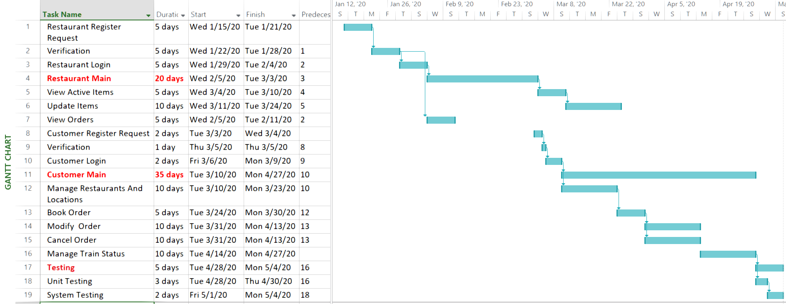

1.10 Hardware and Software Specification

1.11 Tools and technologies used with reasoning

